**# Creating Real Estate Analysis Project in R**

# Sachin Korgaonkar

# Data Science Project

# Dated 5-June-2020

# libraries import

library(ggplot2)

library(ggmap)

library(dplyr)

# Import Mumbai and Navi Mumbai real estate data

# This data is downloaded from kaggle

house.data <- read.csv('Mumbai_realestate_data.csv',header=TRUE)

# Data Cleanup Activity

# The date from this data frame is not required

# Create Data Frame from this data and store as house.data

house.data <- house.data[1:5000,]

attach(house.data)

# Data Exploration

# first view the structure of the data

# See all columns in data frame

glimpse(house.data)

# View a summary of the house data

summary(house.data)

# Put average price as benchmark

# In India INR 10 Lacs are minimum price for household.

pricesIn10Lacs <- house.data$price / 1000000

# Price Distribution

# Find out how Price Distribution is aligned.

# X will show from minimum to maximum price.

# Y will show the approx total numbers (frequency) of prices appear in the list.

# Graph shows which price has maximum demand.

hist(pricesIn10Lacs,

data = house.data,

main = 'Distribution of Price',

xlab = 'Price in INR 10 Lacs',

ylab = 'Demand',

col = 'Sky blue',

bins = 5

)

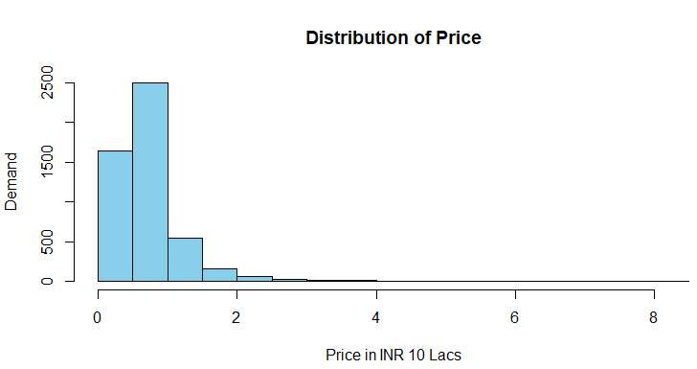

# Bedrooms Distribution

# How many bedroom people demand?

# Graph shows 2.5 to 3 bedroom apartments are more popular

hist(house.data$bedrooms,

main = 'Distribution of Bedrooms',

xlab = 'Number of Bedrooms',

ylab = 'Demand',

col = 'Green'

)

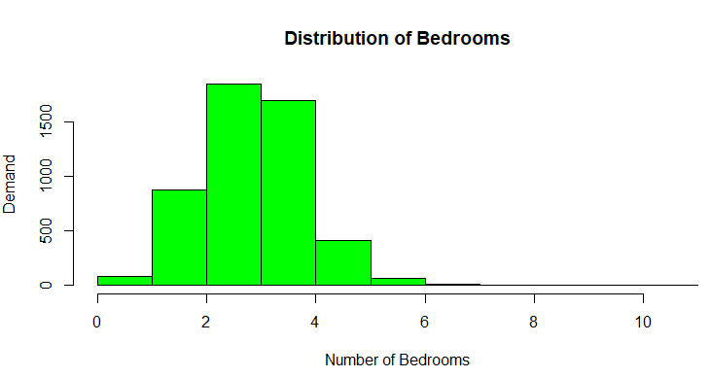

# Identify which location is in our budget

plot(price ~ location,

main = 'Location - Price Comparison',

xlab = 'Locations',

ylab = 'Price in INR 10 Lacs',

col = c('Orange', 'Blue','Green','Yellow','Pink')

)

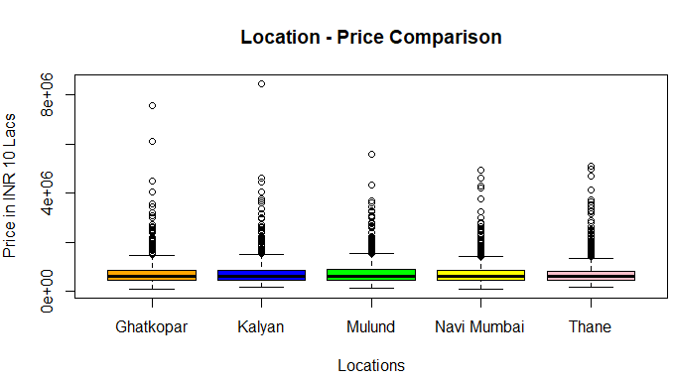

# How popular is society style. Whether people prefer Single tower or township

# Graph Shows people prefer township

hist(house.data$towers,

main = 'Preference of Society Style',

xlab = 'Society Style',

ylab = 'Demand',

col = 'yellow'

)

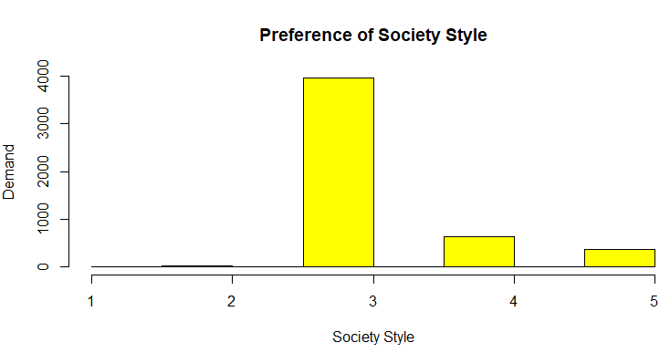

# Put SQFT by 100

squareFt <- house.data$sqft_lot15 /100

# Price by Sqft

plot(y = pricesIn10Lacs,

main = 'Majority demand for size of houses',

x = squareFt,

xlab = 'Square Feet',

ylab = 'Price in INR 10 Lacs'

)

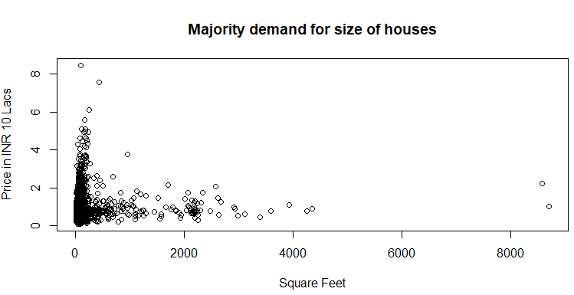

# Prices by bedrooms

plot(pricesIn10Lacs,

bedrooms,

data = house.data,

main = 'Price by Bedroom',

col = 'purple',

xlab = 'Price In INR 10 Lacs',

ylab = 'Number of Bedrooms'

)

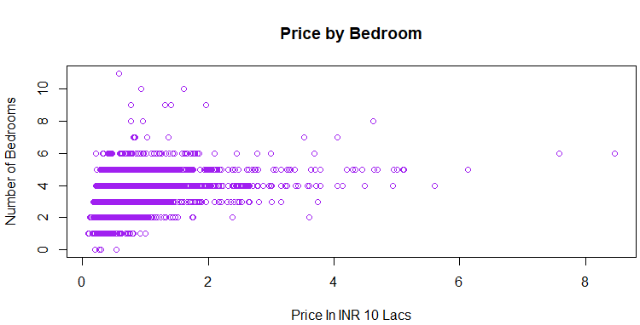

**# 2. MLR Model**

# Drop Date from model,

# create baseline model

house.model <- lm(price ~ ., data = house.data)

summary(house.model)

# Round Coefficient Table

coeffs <- summary(house.model)$coefficients

coeffs <- round(coeffs,4)

coeffs

**# Create a scatter plot**

plot(price ~ yr_built,

data = house.data,

cex = .4,

col = 'red',

main = 'Price by year',

xlab = 'Year',

ylab = 'Price of house in INR 10 Lacs'

)

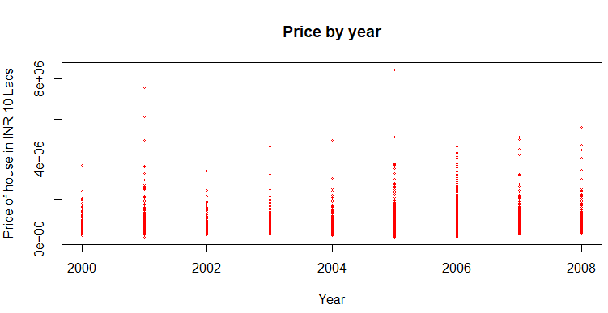

# I want to see if house prices on average vary by quarter centuries

# Grab the price and year to convert year into decade factor

priceByDecade <- data.frame(Price = house.data$price, Decade = house.data$yr_built)

# Find the earliest Year Built

min(priceByDecade$Decade)

[1] 2000

# Find the latest Year built

max(priceByDecade$Decade)

[1] 2008

# Find the Distribution by Year

hist(priceByDecade$Decade,

bins = 10,

main = 'Distribution of Houses By Year',

xlab = 'Year Built',

ylab = 'Count',

col = 'orange'

)

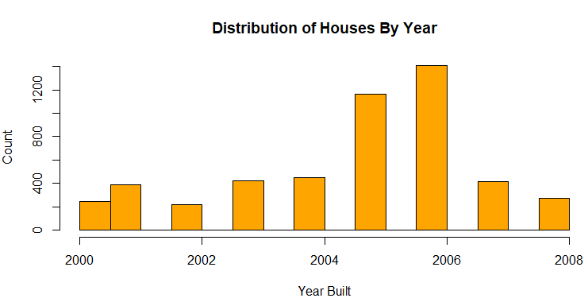

# Create a Break every 25 years

for(i in 1:5000){

if (priceByDecade$Decade[i] < 2005){

priceByDecade$Decade[i] <- '2000 - 2005'

}

else if (priceByDecade$Decade[i] >2005 && priceByDecade$Decade[i] < 2010){

priceByDecade$Decade[i] <- '2005-2010'

}

else{

priceByDecade$Decade[i] <- '2010-Current'

}

}

# Most of the projects are old than 2010

# Make Sure each year is

priceByDecade$Decade <- as.factor(priceByDecade$Decade)

# Creating Analysis of variance (ANOVA)

# ANOVA is a collection of statistical models and their associated estimation procedures

anova <- aov(Price ~ Decade, data = priceByDecade)

summary(anova)

TukeyHSD(anova)

plot(pricesIn10Lacs ~ Decade,

data = priceByDecade,

main = 'ANOVA Price ~ Year Breakup',

xlab = 'Qrt. 2000 - Present',

ylab = 'Price in INR 10 Lacs',

col = c('Orange', 'Blue','Green','Yellow','Pink')

)

